R. Akshaya
192524118
CSA14 COMPILER DESIGN
LAB MANUAL
Exp. No. 1
Develop a lexical Analyzer to identify identifiers, constants, operators using C program.

Program: #include<stdio.h> #include<ctype.h> #include<string.h> int main()
{
int i,ic=0,m,cc=0,oc=0,j;
char b[30],operators[30],identifiers[30],constants[30];
printf("enter the string : ");
scanf("%[^\n]s",&b); for(i=0;i<strlen(b);i++)
{
if(isspace(b[i]))
{
continue;
}
else if(isalpha(b[i]))
{
identifiers[ic] =b[i]; ic++;
}
else if(isdigit(b[i]))
{ m=(b[i]-'0');
i=i+1; while(isdigit(b[i]))
{
m=m*10 + (b[i]-'0'); i++;
}
i=i-1; constants[cc]=m; cc++;
}
else
{
if(b[i]=='*')
{
operators[oc]='*'; oc++;
}
else if(b[i]=='-')
{
operators[oc]='-'; oc++;
}
else if(b[i]=='+')
{
operators[oc]='+'; oc++;
}
else if(b[i]=='=')
{
operators[oc]='='; oc++;
}
}
}
printf(" identifiers : "); for(j=0;j<ic;j++)
{
printf("%c ",identifiers[j]);
}
printf("\n constants : "); for(j=0;j<cc;j++)
{
printf("%d ",constants[j]);
}
printf("\n operators : "); for(j=0;j<oc;j++)
{
printf("%c ",operators[j]);
}
}

Output:
enter the string : a = b + c * e + 100 identifiers : a b c e
constants : 100 operators : = + * +
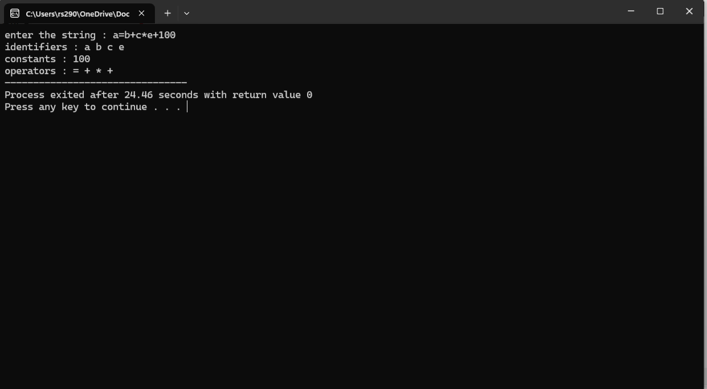
Exp. No. 2
Develop a lexical Analyzer to identify whether a given line is a comment or not using C

Program: #include<stdio.h> #include<conio.h> int main()
{
char com[30]; int i=2,a=0;
printf("\n Enter comment:"); gets(com);
if(com[0]=='/')
{
if(com[1]=='/')
printf("\n It is a comment"); else if(com[1]=='*')
{
for(i=2;i<=30;i++)
{
if(com[i]=='*'&&com[i+1]=='/')
{
printf("\n It is a comment"); a=1;
break;
}
Else
continue;
}
if(a==0)
printf("\n It is not a comment");
}
else
printf("\n It is not a comment");
}
else
printf("\n It is not a comment");
}

Output:
Input: Enter comment: //hello Output: It is a comment Input: Enter comment: hello Output: It is not a comment
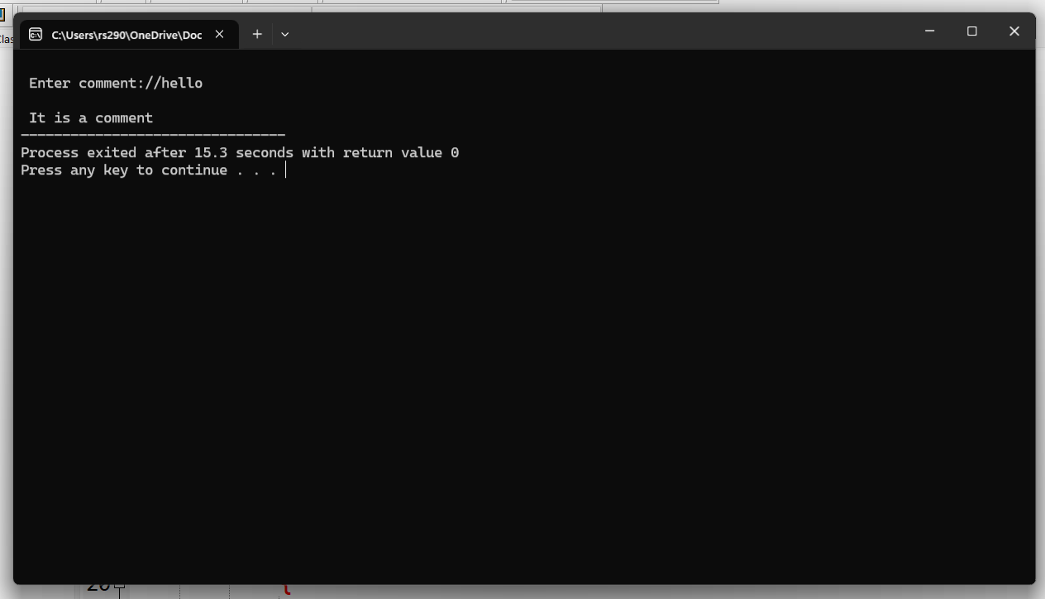
Exp. No. 3
Design a lexical Analyzer for given language should ignore the redundant spaces, tabs and new lines and ignore comments using C

Program:
#include<stdio.h>
#include<stdlib.h>
#include<string.h>
#include<ctype.h>
int isKeyword(char buffer[]){ char keywords[32][10] =
{"main","auto","break","case","char","const","continue","default",
"do","double","else","enum","extern","float","for","goto",
"if","int","long","register","return","short","signed",
"sizeof","static","struct","switch","typedef",
"unsigned","void","printf","while"}; int i, flag = 0;
for(i = 0; i < 32; ++i)
{
if(strcmp(keywords[i], buffer) == 0)
{
flag = 1; break;
}
}
return flag;
}
int main()
{
char ch, buffer[15], operators[] = "+-*/%="; FILE *fp;
int i,j=0;
fp = fopen("flex_input.txt","r"); if(fp == NULL){
printf("error while opening the file\n");
exit(0);
}
while((ch = fgetc(fp)) != EOF){ for(i = 0; i < 6; ++i){
if(ch == operators[i]) printf("%c is operator\n", ch);
}
if(isalnum(ch)){ buffer[j++] = ch;
}
else if((ch == ' ' || ch == '\n') && (j != 0)){ buffer[j] = '\0';
j = 0;
if(isKeyword(buffer) == 1) printf("%s is keyword\n", buffer); else
printf("%s is identifier\n", buffer);
}
}
fclose(fp); return 0;
}
Input: flex_input.txt main ( )
{
int a, b, c ; c = b + c;
printf ( "%d" ,c ) ;
}
Output:
main is keyword int is keyword
a is indentifier
b is indentifier
c is indentifier c is indentifier
= is operator b is indentifier
+ is operator c is indentifier
printf is keyword
% is operator d is indentifier c is indentifier

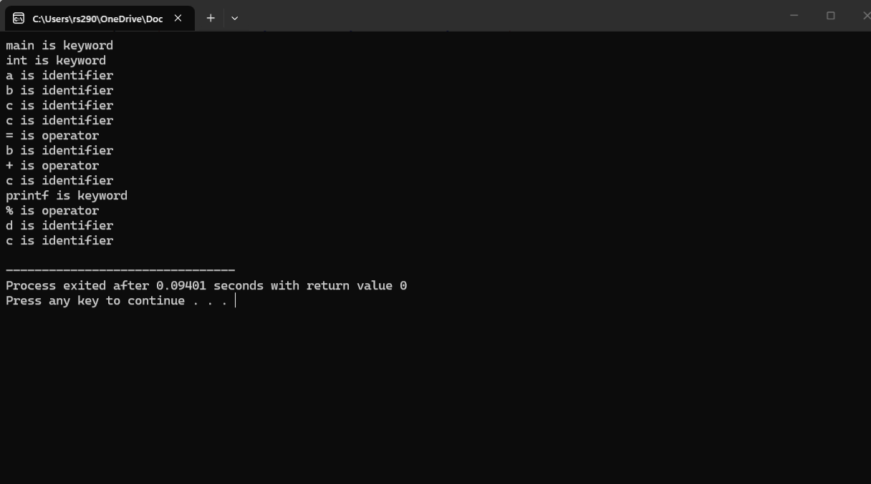
Exp. No. 4
Design a lexical Analyzer to validate operators to recognize the operators +,-,*,/ using regular arithmetic operators using C

Program: #include<stdio.h> #include<conio.h> int main()
{
char s[5];
printf("\n Enter any operator:"); gets(s);
switch(s[0])
{
case'>':
if(s[1]=='=')
printf("\n Greater than or equal");
else
printf("\n Greater than");
break; case'<':
if(s[1]=='=')
printf("\n Less than or equal");
else
printf("\nLess than");
break; case'=':
if(s[1]=='=')
printf("\nEqual to");
else
printf("\nAssignment");
break; case'!':
if(s[1]=='=')
printf("\nNot Equal");
else
printf("\n Bit Not");
break; case'&':
if(s[1]=='&')
printf("\nLogical AND");
else
printf("\n Bitwise AND");
break; case'|':
if(s[1]=='|')
printf("\nLogical OR");
else
printf("\nBitwise OR");
break; case'+':
printf("\n Addition"); break;
case'-':
printf("\nSubstraction"); break;
case'*':
printf("\nMultiplication"); break;
case'/':
printf("\nDivision"); break;
case'%':
printf("Modulus"); break;
default:
printf("\n Not a operator");
}
}
Output:
Enter any operator:<= Less than or equal
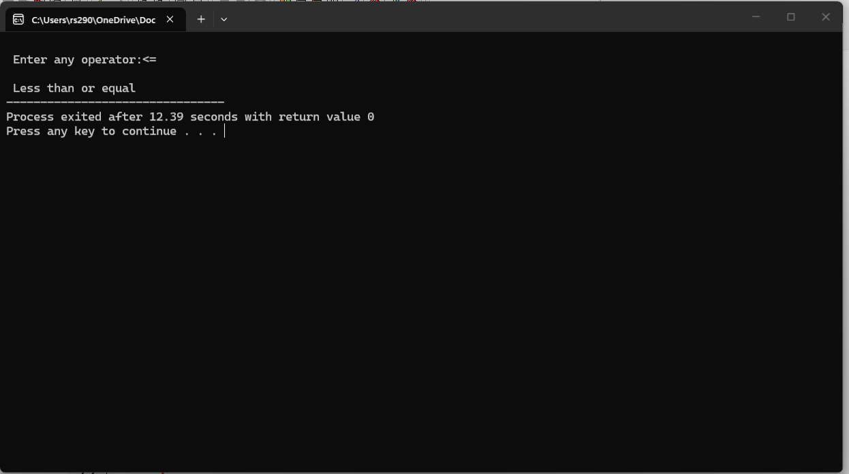
Exp. No. 5
Design a lexical Analyzer to find the number of whitespaces and newline characters using C.
Program:
#include <stdio.h>
int main() { char str[100];
int words = 0, lines = 0, characters = 0;
printf("Enter text (up to 100 characters, use ~ to end):\n"); scanf("%[^~]", str);
for (int i = 0; str[i] != '\0'; i++) {
if (str[i] == ' ' || str[i] == '\t') { words++;
} else if (str[i] == '\n') { lines++;
} else {
characters++;
}
}
// Check for an empty input if (characters > 0) {
words++; // If there are characters, there is at least one word lines++; // If there are characters, there is at least one line
}
printf("Total number of words: %d\n", words); printf("Total number of lines: %d\n", lines); printf("Total number of characters: %d\n", characters);
return 0;
}
Output:
void main()
{
int a; int b;
a = b + c; c = d * e;
}
Total number of words : 12 Total number of lines : 7
Total number of Character: 34
